**VirtualEye-Lifeguard for Swimming Pools to Detect the**

**Active Drowning**

**A MINI PROJECT REPORT**

# **PNT2022TMID36960**

***Submitted by***

## KEERTHANA.U.R(211919106003) THAMIZHINIYAN.T(211919106306)

## JAYAPREETHA.R(211919106002) MAHENDRAN.R(211919106304)

## MOURIYA.J(211919106004)

***In partial fulfillment for the award of the degree***  ***of***

**BACHELOR OF ENGINEERING**

**IN**

**ELECTRONICS AND COMMUNICATION ENGINEERING**

**RAJIV GANDHI COLLEGE OF ENGINEERING**

**SRIPERUMBUDUR, KANCHIPURAM – 602 105**

**ANNA UNIVERSITY:: CHENNAI – 600 025** **NOV/DEC 2022**

**CHAPTER-1**

### 1.1 INTRODUCTION

Recently, there has been growing interest around the topic of drowning detection systems (DDS) in the sport and leisure industry both across the UK and globally. Advancements in technology, coupled with the importance of pool safety, has led to its growing prominence, with mention of DDS now in documents such as HSG179 - the latest UK standards document for health and safety in swimming pools (Health and Safety Executive, 2018). However, the topic is a debated area for various reasons explored in this review.

Whilst there are plenty of academic articles dedicated to the technology and design behind these products in the fields of biometrics, computer science and electronic engineering, there is limited academic research investigating their application to real-world scenarios. Furthermore, there is uncertainty around their use alongside traditional lifeguarding; whether international testing standards (ISO standards) are robust enough; and general risks affecting the effectiveness of these products. This includes factors such as water clarity, high pool occupancy, lighting, glare and attractions such as water slides and wave machines.These concerns alongsidethe lack of research and high installation costs have resultedin a reluctance by some operators to incorporate DDS into their pools. This signifies the importance of independent research into DDS. intends to support the move towards the shared goal of improved pool safety.

This piece will begin with an overviewof the different definitions of DDS, followed by an explanation of the aims and methodology of this review. It will then discuss what the current DDS standards are alongside legislation and guidance availablearound DDS, and provide a summary of the sharedresponsibilities towardsthe effective operation of DDS. Following this, the literature review will examinethe co-existence betweenDDS and traditional lifeguarding, provide an analysis of its impact so far, and concludewith recommendations on the directionof future DDS research. **Project Overview**

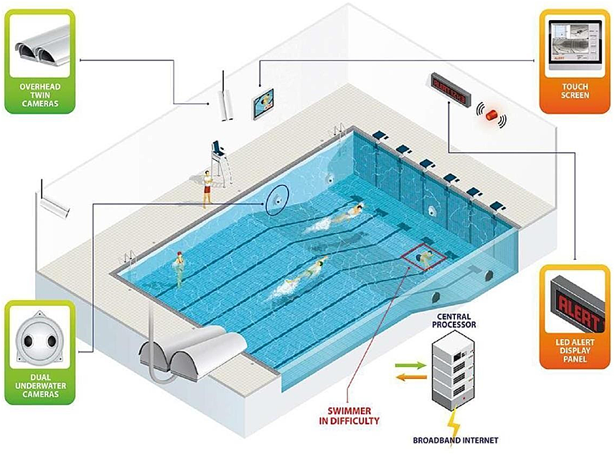

### Purpose

Establish and outline what is known on DrowningDetection Systems.Evaluate the current literature on Drowning DetectionSystems, including their use in indoor pool environments along with interaction with traditional lifeguarding. Better understand where DDS are positioned in the health and safety landscape of indoor swimmingpools. The value that can be generated from these aims stem from the recognition that currently, there are no published documents drawing together all the currentDDS research. The literature review aims to contribute as independent research in this field and hopes to signpost the potential future directionof DDS research. **CHAPTER-2**

### 2.1 LITERATURE SURVEY

The differing definitions of DDS, most outline three defining elements:

1. surveillance,
2. detection of a pool user in difficulty, and
3. raising an alarm

For example, ISO_20380 (the document published by the International Organisation for Standardization (2017) outlining the international safety requirements and test standards for DDS) defines the technology as an ‘automated system including means for digitizing series of images of peoplein the pool basin, means for comparing and analysing digitized images and decision means for setting off and sending an alarm to trained staff when adetection occurs’. In comparison, there are broader definitions that areinclusive of other technologies that focus on the surveillance aspect, for example, ‘DDS is used to describe various electronic systems that are designed to assist with the surveillance of swimmers within the water of a swimmingpool’ (Sport England,2011). This definition would include CCTV that helps give lifeguards an underwater view but does not have the capacity to detect a pool user in difficulty or raise an alarm. For this to be effective, staff would have to make sure the CCTV is being monitored at all times, making the staff experience with this very different to the experience of using a DDS fallingunder the first definition. It is important to distinguish what exactly constitutes a DDS as there are different areas of responsibility required from different actors involved in the effective operation of DDS, which will be examined in chapter 4. For this literature review,research has focusedon the definition used by the ISO and othersources that incorporate all three elementsof surveillance, detection and alarm raising.

#### 2.2 Existing Problem

Whilst literature on DDS mostly agrees on areas such as the risks and issues associated with DDS performance, there are other areas where sources offer differing points of view, for example, DDS and their co- existence with lifeguards. There is debate around whether DDS can be helpful or harmful towardslifeguarding practices and how DDS may changethe landscape of traditional lifeguarding, as well as some disagreement on whether they serve as justification for reducing lifeguardnumbers. The term ‘blended lifeguarding’ or ‘modern lifeguarding’ has been newly coined to describethe concept of traditional lifeguarding practices being blendedwith technology for drowning detection

(Swimming Pool Scene, 2017).

Currently, thereis little qualitative or quantitative researchanalysing the experiences of lifeguards themselves relating to this concept.

#### 2.3 References

1. AngelEye. (2019). AngelEye – Distributors. Retrieved from: https://[www.angeleye.it/news.](http://www.angeleye.it/news) php?id=28&newscat=10

1. Aquatics International. (2007). Traumatic Experiences – Should we make our youngest lifeguards come face to face with death? Retrieved

from: [https://www.aquaticsintl.com/facilities/traumatic ex](https://www.aquaticsintl.com/facilities/traumatic%20ex)p[eriences_o](https://www.aquaticsintl.com/facilities/traumaticexperiences_o)

1. British Standards Institution. (2018). BS EN 15288-1, Swimming pools for public use. Safety requirements for design. Retrieved from:

[https://shop.bsigroup.com/ProductDetail/?pid=00000000](https://shop.bsigroup.com/ProductDetail/?pid=000000000030360254)

[0030360254](https://shop.bsigroup.com/ProductDetail/?pid=000000000030360254)

1. British Standards Institution 1. (2018).BS EN 15288-2, Swimming pools for public use. Safety requirements for operation. Retrieved from: https://shop.bsigroup.com/ProductDetail/?p

id=000000000030360257

1. Drowning Prevention. (2017).The Need. Retrieved from: <https://www.drowningprevention.com.au/>

1. German Institute for Standardization. (2019). German national guideline DGfdBR 94.15 “Test methods for camera-based drowning detection systems under operational conditions” (German Association for Public

Swimming Pools).

1. Haizhou Li, HaizhouLi, Kar-Ann Toh and Liyuan Li. (2012).Advanced Topics in Biometrics, World Scientific

Publishing Co. Pte. Ltd., ISBN-13 978-981-4287-84-5

1. Health and Safety Executive. (2018). HSG179, Health and safety in swimming pools (Fourth edition).

1. ISO (2017) ISO_20380, First edition, Public swimming pools — Computer vision systems for the detection of drowning accidents in swimming pools —

Safety requirements and test methods.

#### 2.4 PROBLEM STATEMENT DEFINITION

1. Swimming is one of the best exercises that helps people to reduce stress in this urban lifestyle. Swimming pools are found larger in number in hotels.

1. Applying the CNN algorithm to the dataset. Beginners, especially, often feel it difficult to breathe underwater which causes breathing trouble which in turn causes a drowning accident.

1. To overcome this conflict, a meticulous system is to be implemented along the swimming pools to save human life.

**CHAPTER-3**

**3.1 IDEATION & PROPOSEDSOLUTION**

**EMPATHY MAP CANVAS**

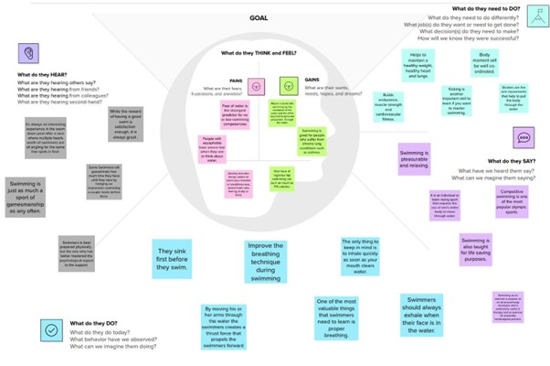

**IDEATION & BRAINSTORMING**

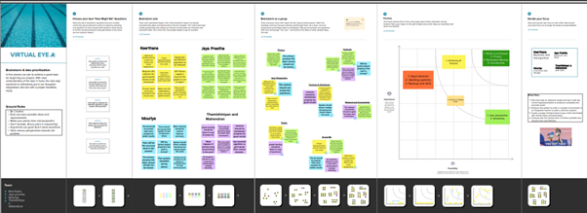

**PROPOSED SOLUTION**

**Proposed Solution Template:**

|  |  |  |
| --- | --- | --- |
| **S.No.** | **Parameter** | **Description on** |
| 1. | Problem Statement (Problem to be solved) | People use the swimming for enjoyment, health Exercise but for all age of the people pool is really dangerous we need lifeguard, in duty  swimming pools are very dangerous in the underwater. |
| 2. | Idea / Solu on description | In this project, using Artificial intelligence technology, using the camera help we can detect the people ac on and posions and also we check breathing level of the people inside the underwater and use of any alarms system  we can detect the some of them are in the problem |
| 3. | Novelty / Uniqueness | The uniqueness of the our system is track the people posi on and body condition in the  drowning using YOLO Algorithm. It is fast and very speed in the detect on |
| 4. | Social Impact/ Customer Satisfaction | In world most of them are unexcepted cause very serious death in the underwater not only in the city but most occurs in the rural area in the public places(well, lakes) we should avoid the accident in the underwater drowning |
| 5. | Business Model (Revenue Model) | In the so ware field this well increase good income. Safety innova on in the swimming  related issues this makes a rac ve for end users to use our so ware product |
| 6. | Scalability of the Solu on | IBM cloud server will collect all the data and stored in the server. This will more safe and secure |

**PROBLEM SOLUTIONFIT**

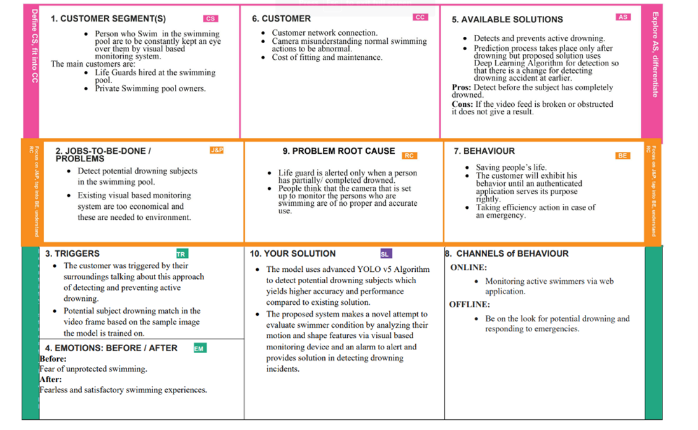

**CHAPTER-4**

**4.1 REQUIREMENT ANALYSIS**

**FUNCTIONAL REQUIREMENT**

|  |  |  |
| --- | --- | --- |
| **FR No.** | **Functional Requirement (Epic)** | **Sub Requirement (Story / Sub-Task)** |
| FR-1 | Installation | Needed to be fixed under the water in the swimming pool |
| FR-2 | Detection | Either horrified or in unconscious |
| FR-3 | Audio | Ask for help or stay quiet if the person is unconscious |
| FR-4 | Support | Take swim tubes or take the help of rescuer |
| FR-5 | Prior Alert | Send alert message to the lifeguard |
| FR-6 | Pulse rate sensor | Detect the pulse rate of a swimmer |

**NON-FUNCTIONAL REQUIREMENT**

|  |  |  |
| --- | --- | --- |
| **FR No.** | **Non-Functional Requirement** | **Description** |
| NFR-1 | **Usability** | To ensure the safety of each and every person present in the pool. A Lifeguard should be present all the time in the pool. |
| NFR-2 | **Security** | Lifeguards should be aware of the alert message to save the life of the swimmer |
| NFR-3 | **Reliability** | Virtual eye lifeguard triggers an immediate prior alarm if a swimmer is in peril, helping to avoid panic even in critical situations. |
| NFR-4 | **Performance** | The performance of the tool works better than available tools |
| NFR-5 | **Availability** | Equipment and accessories include lifesaver rings, inflatable vests, life hooks, spine boards, rescue tubes, and a first aid kit. |
| NFR-6 | **Scalability** | Virtual eye lifeguard detects potential drowning and promptly notifies you. It features the latest artificial intelligence technology and adapts to the needs of the  user. |

## CHAPTER-5

**5.1 PROJECT DESIGN**

**DATAFLOW DIAGRAMS**

**Data Flow Diagrams:**

A Data Flow Diagram (DFD) is a tradi onal visual representa on of the informa on flows within a system. A neat and clear DFD can depict the right amount of the system requirement graphically. It shows how data enters and leaves the system, what changes theinforma on, and where data is stored

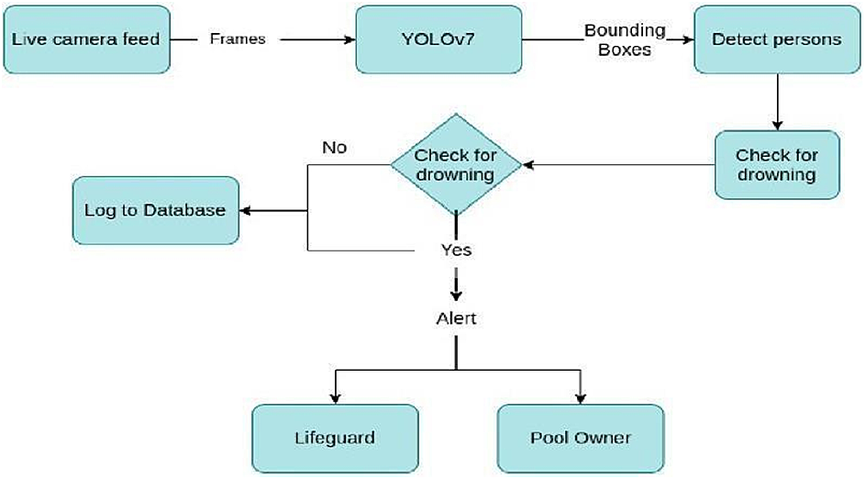

**SOLUTION & TECHNICAL ARCHITECTURE**

**Solution Architecture:**

Usually, such systems can be developed by installing more than 16 cameras underwater and ceiling and analyzing the video feeds to detect any anomalies. AS a POC we make use of one camera that streams the video underwater and analyses the posion of swimmers to assess the probability of drowning, if it is higher then an alert will be generated to a react lifeguards' on.

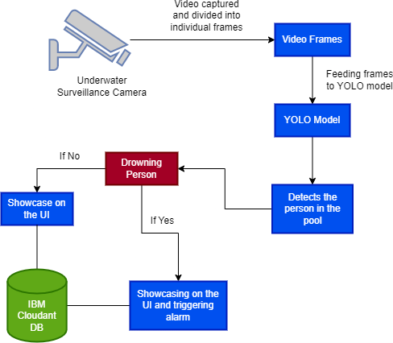

**USER STORIES**

|  |  |  |  |  |  |  |
| --- | --- | --- | --- | --- | --- | --- |
| **User Type** | **Functional Requirement (Epic)** | **User Story Number** | **User Story / Task** | **Acceptance criteria** | **Priority** | **Release** |
| Customer  (Pool owner) | Installation | USN-1 | As a pool owner, I can install the cameras and  set up the drowning detection system | I can connect the cameras  to the cloud-hosted software | High | Sprint-1 |
|  | Detecting the drowning persons | USN-2 | As a user, I can find the drowning persons by using the drowning detection system | I would receive an alert if a person is drowning | High | Sprint-1 |
|  | Notify the lifeguard | USN-3 | As a user, I can notify the lifeguard when the system detects a drowning person | I can set up an alarm that would notify the lifeguard | High | Sprint-2 |
| Customer  (Lifeguard) | Rescue people | USN-4 | As a user, I can rescue the drowning persons  from the pool | I can save the drowning  person | High | Sprint-2 |
| Customer  (Swimmers) | Safety | USN-5 | As a user, I can swim without the fear of  Drowning | I can swim safely with the  help of the system and the lifeguard | Medium | Sprint-2 |
| Customer Care  Executive | Contact | USN-6 | resolve technical issues | I can contact the customer  care executive to resolve any issues | Medium | Sprint-3 |
| Adminitsrator | Dashboard | USN-7 | Management of the drowning detection  system and database management. | I can access the system’s  logs and any other data instantly | High | Sprint-4 |

## CHAPTER-6

**SPRINT PLANNING & ESTIMATION**

|  |  |  |  |  |  |  |
| --- | --- | --- | --- | --- | --- | --- |
| **Sprint** | **Total**  **Story Points** | **Duration** | **Sprint**  **StartDate** | **Sprint**  **End Date**  **(Planned)** | **Story Points**  **Completed**  **(as on**  **PlannedEnd**  **Date)** | **Sprint**  **Release**  **Date(Actual)** |
| Sprint-1 | 8 | 6 Days | 24 Oct 2022 | 29 Oct 2022 | 6 | 29 Oct 2022 |
| Sprint-2 | 14 | 6 Days | 31 Oct 2022 | 05 Nov 2022 | 12 | 05 Nov 2022 |
| Sprint-3 | 16 | 6 Days | 07 Nov 2022 | 12 Nov 2022 | 11 | 12 Nov 2022 |
| Sprint-4 | 12 | 6 Days | 14 Nov 2022 | 19 Nov 2022 | 12 | 19 Nov 2022 |

**SPRINT DELIVERY SCHEDULE**

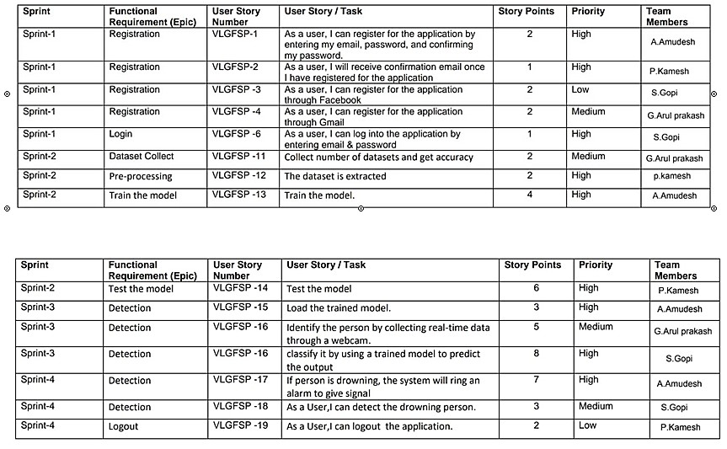

**REPORT FROM JIRA Backlog (scrum)**

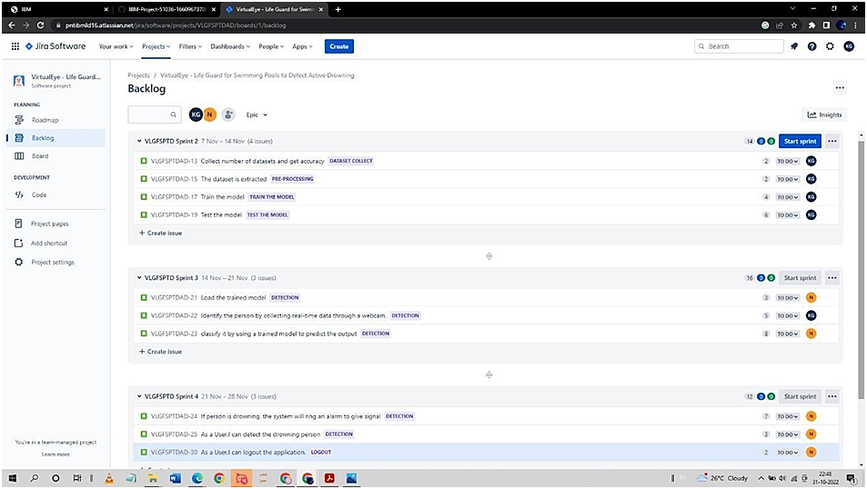

**Roadmap**

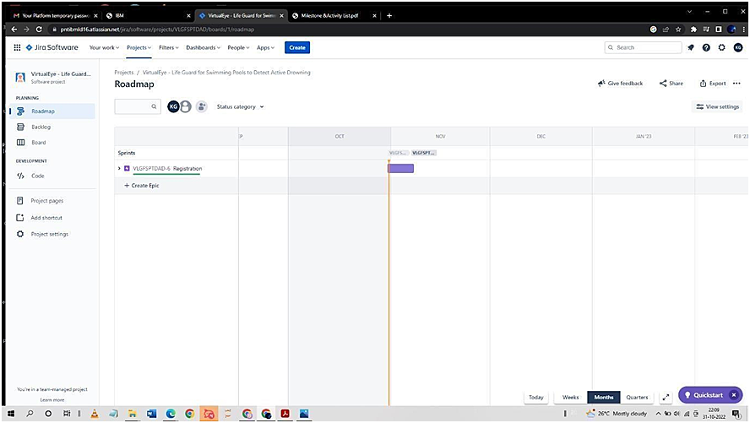

**Chart**

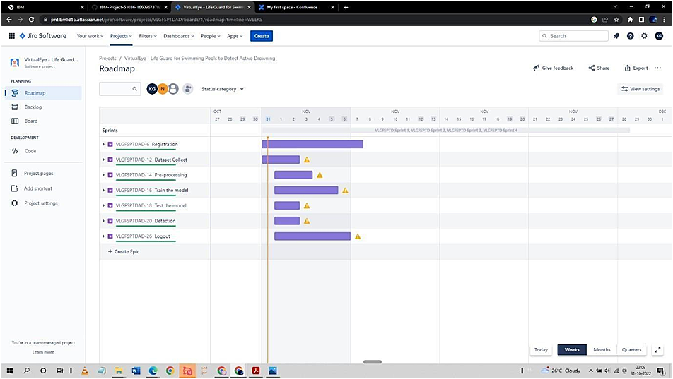

**Board (Kanban)**

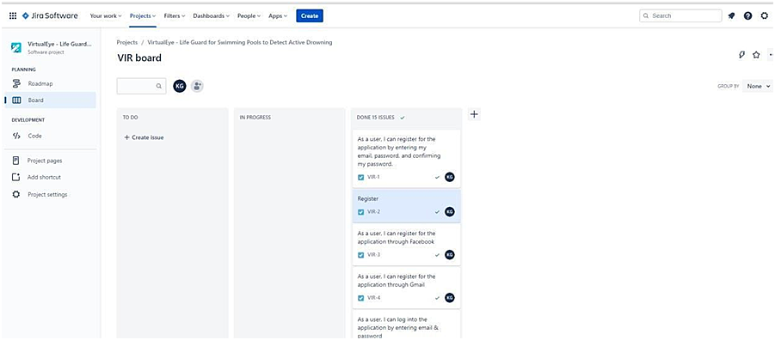

## CHAPTER-7

**7.1CODING & SOLUTION**

**FEATURE**

#import necessary packages import cv2 import os import numpy as np

from .utils import download_file

initialize = Truenet = None

dest_dir = os.path.expanduser('~') + os.path.sep + '.cvlib' + os.path.sep + 'object_detection' +os.path.sep + 'yolo' + os.path.sep + 'yolov3' classes = None

#colors are BGR

instead of RGB in python

COLORS =

[0,0,255],

[255,0,0]

def populate_class_labels():

#we are using a pre existent classifier which is more reliable and more efficient than one#we could make using only a laptop

#The classifier should be downloaded automatically when you run this scriptclass_file_name = 'yolov3_classes.txt' class_file_abs_path = dest_dir + os.path.sep + class_file_name

url =

'https://github.com/Nico31415/DrowningDetector/raw/master/yolov3.txt'if not os.path.exists(class_file_abs_path): download_file(url=url, file_name=class_file_name, dest_dir=dest_dir)f = open(class_file_abs_path, 'r') classes = [line.strip() for line in f.readlines()]

return classes

def get_output_layers(net)

#the number of output layers in a neural network is the number of possible#things the network can detect, such as a person, a dog, a tie, a phone... layer_names = net.getLayerNames()

output_layers = [layer_names[i[0] - 1] for i in

net.getUnconnectedOutLayers()]

return output_layers

def draw_bbox(img, bbox, labels, confidence, Drowning,write_conf=False):

if classes is None:

classes = populate_class_labels()

for i, labelin enumerate(labels):

#if the person is drowning, the box will be drawn red instead of blueif label ==

'person'and Drowning: color = COLORS[0] label

= 'DROWNING'

else:

color = COLORS[1]

if write_conf: label += ' ' + str(format(confidence[i] * 100, '.2f')) +'%'

#you only need to points (the opposite corners) to draw a rectangle. These points#are stored in the variable bbox cv2.rectangle(img, (bbox[i][0],bbox[i][1]), (bbox[i][2],bbox[i][3]), color,2)

cv2.putText(img, label, (bbox[i][0],bbox[i][1]-10), cv2.FONT_HERSHEY_SIMPLEX, 0.5, color, 2) return img

def

detect_common_objects(image,

confidence=0.5, nms_thresh=0.3):

Height, Width

= image.shape[:2

]scale =

0.00392

#all the weights and the neuralnetwork algorithm are already preconfigured#as we are using YOLO

#this part of the script just downloads the

YOLO

filesconfig_file_name =

'yolov3.cfg' config_file_abs_path = dest_dir+ os.path.sep + config_file_name weights_file_name = 'yolov3.weights'

weights_file_abs_path = dest_dir+

os.path.sep + weights_file_name

url = 'https://github.com/Nico31415/DrowningDetector/raw/master/yolov3.cfg'

if not os.path.exists(config_file_abs_path): download_file(url=url, file_name=config_file_name, dest_dir=dest_dir)

url = 'https://pjreddie.com/media/files/yolov3.weights'

if not os.path.exists(weights_file_abs_path):

download_file(url=url, file_name=weights_file_name,dest_dir=dest_dir)

if initialize:

classes = populate_class_labels()

net = cv2.dnn.readNet(weights_file_abs_path, config_file_abs_path)initialize = False

blob = cv2.dnn.blobFromImage(image,scale, (416,416), (0,0,0), True, crop=False)

net.setInput(blob)

outs = net.forward(get_output_layers(net))

class_ids = [] confidences = [] boxes= []

for out in outs:

for detect ion in out: scor es = detect ion[5

:]

class_id = np.argm ax(score

s)

max_co

nf = scores[cl ass_id] if

max_co

nf > confiden

ce: **CHAPTER-8**

### 8.1 TESTING

#### TEST CASES

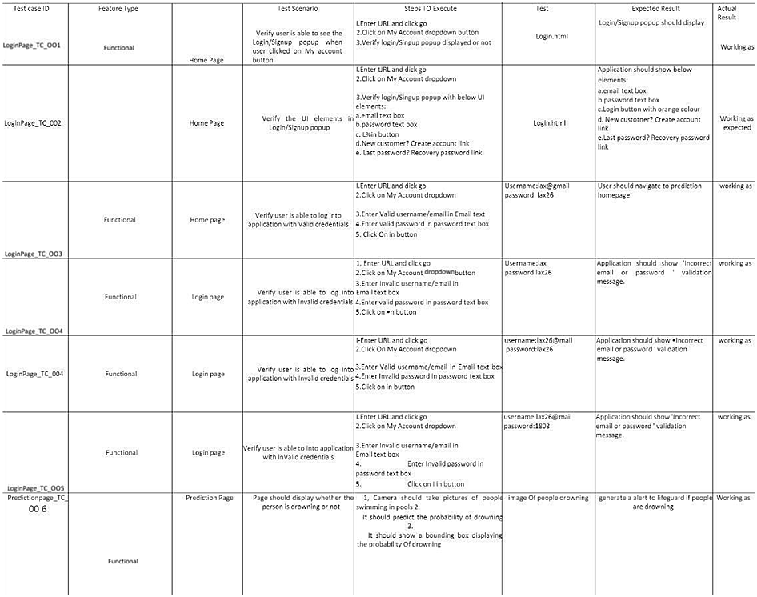

**USER ACCEPTANCE TESTING**

#### Purpose of Document

The purpose of this document is to briefly explain the testcoverage and open issues of the

[ProductName] project at the me of the releaseto User Acceptance Tes ng(UAT).

#### Defect Analysis

Thisreport shows the number of resolved or closed bugs at each severity level,and howthey wereresolved

|  |  |  |  |  |  |
| --- | --- | --- | --- | --- | --- |
| **Resolution** | **Severity 1** | **Severity 2** | **Severity 3** | **Severity 4** | **Subtotal** |
| By Design | 7 | 3 | 1 | 2 | 13 |
| Duplicate | 1 | 0 | 2 | 0 | 3 |
| External | 2 | 3 | 0 | 1 | 6 |
| Fixed | 10 | 2 | 4 | 10 | 26 |
| Not Reproduced | 0 | 0 | 1 | 0 | 1 |
| Skipped | 0 | 0 | 1 | 1 | 2 |
| Won't Fix | 0 | 5 | 2 | 1 | 8 |
| Totals | 24 | 14 | 13 | 26 | 77 |

Test Case Analysis

This report shows the number of test cases that have passed, failed,and untested

|  |  |  |  |  |
| --- | --- | --- | --- | --- |
| **Section** | **Total Cases** | **Not Tested** | **Fail** | **Pass** |
| Print Engine | 7 | 0 | 0 | 7 |
| Client Application | 1 | 0 | 0 | 41 |
| Security | 42 | 0 | 0 | 42 |
| Outsource Shipping | 3 | 0 | 0 | 3 |
| Exception Reporting | 9 | 0 | 0 | 9 |
| Final ReportOutput | 4 | 0 | 0 | 4 |
| Version Control | 2 | 0 | 0 | 2 |

<html lang="en">

<head>

<meta charset="UTF-8">

<meta name="viewport" content="width=device-width, initial-scale=1.0">

<meta http-equiv="X-UA-Compatible" content="ie=edge">

<title>High QualityFacial Recognition</title>

<link href="https://cdn.bootcss.com/bootstrap/4.0.0/css/bootstrap.min. css" rel="stylesheet">

<script src="https://cdn.bootcss.com/popper.js/1.12.9/umd/popper.min.js">

</script>

<script src="https://cdn.bootcss.com/jquery/3.3.1/jquery.min.js">

</script>

<script src="https://cdn.bootcss.com/bootstrap/4.0.0/js/bootstrap.min.js">

</script>

<link href="{{ url_for('static', filename='css/main.css') }}"rel="stylesheet">

<style>

.bg-dark { background-color: #42678c!important; }

#result { color: #0a1c4ed1;

</head>

}

</style>

<body style="background-color:black";> <header id="head" class="header"> <section id="navbar">

<h1 class="nav-heading"></i>Virtual Eye</h1>

<div class="nav--items">

<ul>

<li><a href="{{ url_for('index')}}">Home</a></li>

<li><a

href="{{ url_for('logout')}}">Logout</a></li>

<!-- <li><a href="#about">About</a></li>

<li><a href="#services">Services</a></li> -->

</ul>

</div>

</section>

</header>

<div class="container">

<div id="content" style="margin-top:2em">

<div class="container"> <div class="row">

<div class="col-sm-6 bd" >

<h2><em style="color:white;">High Quality Facial Recognition</em></h2>

<br>

<p><h5><i style="color:white;">Emotion Detection Through Facial FeatureRecognition</i></h5></p>

<img

src="https://130e178e8f8ba617604b-

8aedd782b7d22cfe0d1146da69a52436.ssl.cf1.rackcdn.com/facial- recognition- use-triggers-gdpr-fine-showcase_image-10-a- 12991.jpg" style="height:240px"class="img-rounded" alt="Gesture">

</div>

<div class="col-sm-6">

<div>

Image Here</h4>

<h4 style="color:white;">Upload

<form action = "http://localhost:5000/" id="upload-file"

method="post" enctype="multipart/form-data">

<label for="imageUpload" class="upload-

label">

</label>

Choose Image

<input type="file" name="image"

id="imageUpload" accept=".png, .jpg, .jpeg,.pdf">

</form>

<div class="image-section" style="display:none;"> <div class="img-preview">

<div id="imagePreview">

</div>

</div>

<div>

<buttontype="button" class="btn btn-info

btn-lg " id="btn-predict">Analyse</button>

</div>

</div>

<div class="loader" style="display:none;"></div>

<h3></h3>

<span id="result"> </span>

</div>

</div>

</div>

</body>

</div>

</div>

</div>

<footer>

<script src="{{ url_for('static', filename='js/main.js') }}" type="text/javascript"></script>

</footer>

</html>

##### Index.html

<!DOCTYPE html>

<html lang="en"> <head>

<meta charset="UTF-8">

<meta http-equiv="X-UA-Compatible" content="IE=edge">

<meta name="viewport" content="width=device-width, initial-scale=1.0">

<!--Bootstrap -->

<link rel="stylesheet" href="https://maxcdn.bootstrapcdn.com/bootstrap/4.0.0/css/boo tstrap.min.css" integrity="sha384-

Gn5384xqQ1aoWXA+058RXPxPg6fy4IWvTNh0E263XmFcJlSA

wiGg FAW/dAiS6JXm" crossorigin="anonymous">

<script src="https://code.jquery.com/jquery-

3.2.1.slim.min.js" integrity="sha384-

KJ3o2DKtIkvYIK3UENzmM7KCkRr/rE9/Qpg6aAZGJwFDMVNA/GpG

FF93hXpG5KkN" crossorigin="anonymous"></script>

<script

src="https://cdnjs.cloudflare.com/ajax/libs/popper.js/1.12.9/umd/

popper.min.js" integrity="sha384-

ApNbgh9B+Y1QKtv3Rn7W3mgPxhU9K/ScQsAP7hUibX39j7fak

FPsk vXusvfa0b4Q" crossorigin="anonymous"></script>

<script src="https://maxcdn.bootstrapcdn.com/bootstrap/4.0.0/js/bootst rap.min.js" integrity="sha384-

JZR6Spejh4U02d8jOt6vLEHfe/JQGiRRSQQxSfFWpi1MquVdAyjUar5 +76PVCmYl" crossorigin="anonymous"></script>

<script

src="https://kit.fontawesome.com/8b9cdc2059.js" crossorigin="anonymous"></script>

<link

href="https://fonts.googleapis.com/css2?family=Akronim&family= Roboto&display=swap" rel="stylesheet">

<link rel="stylesheet" href="../static/style.css">

<!-- <script defer src="../static/js/main.js"></script> -->

<title>Virtual Eye</title>

</head> <body>

<header id="head" class="header">

<section id="navbar">

<h1 class="nav-heading"></i>Virtual Eye</h1>

<div class="nav--items">

<ul>

<li><a

href="{{ url_for('index')}}">Home</a></li>

<li><a

href="{{ url_for('login')}}">Login</a></li>

<li><a

href="{{ url_for('register')}}">Register</a></li>

<li><a href="{{ url_for('login')}}">Demo</a></li> </ul> </div>

</section>

<section id="slider">

<div id="carouselExampleIndicators" class="carousel" data-ride="carousel">

<ol class="carousel-indicators ">

<li data-target="#carouselExampleIndicators" data-slide- to="0" class="active "></li>

<li data-target="#carouselExampleIndicators" data-slide-to="1"></li>

<li data-target="#carouselExampleIndicators" data-slide-to="2"></li>

</ol>

<div class="carousel-inner">

<div class="carousel-item active">

<img class="d-block w-100" src="../static/img/1.png"alt="First slide">

</div>

<div class="carousel-item">

<img class="d-block w-100"

src="../static/img/second.jpg" alt="Second slide">

</div>

<div class="carousel-item">

<img class="d-block w-100" src="../static/img/third.jpg"alt="Third slide">

</div>

</div>

<a class="carousel-control-prev" href="#carouselExampleIndicators" role="button" data-slide="prev">

<span class="carousel-control-prev-icon" aria- hidden="true"></span>

<span class="sr-only">Previous</span>

</a>

<a class="carousel-control-next" href="#carouselExampleIndicators" role="button" data-slide="next">

<span class="carousel-control-next-icon" aria- hidden="true"></span>

<span class="sr-only">Next</span>

</a>

</div>

</section>

</header>

<section id="about">

<div class="top">

<h3 class="title textmuted"> ABOUT PROJECT

</h3>

<div class="line"></div>

</div>

<div class="body">

<div class="left">

<h2>Problem:</h2>

<p>

Swimming is one of the best exercises that helps people to reduce stress in this urban lifestyle. Swimming pools are found larger in number in the hotels, weekend touristspots and barelypeople have in their house backyard. Beginners, especially oftenfeel it difficult to breathe under water and causes breathing trouble which in turn cause a drowning accident. Worldwide, drowningproduces a higher rate of mortality without causing injury to children. Children under six of their age arefound to besuffering the highest drowningmortality rates worldwide..Such kinds of deaths account for the third cause of unplanned death globally, with about 1.2 million cases yearly.

</p>

</div>

<div class="left">

<h2>Solution:</h2>

<p>

To overcome the conflict, a meticulous systemis to be implemented alongthe swimming pools to save the human life. Bystudying body movement patterns and connecting cameras to an artificial intelligence (AI)system we can devise an underwater poolsafety system that reduces the risk of drowning. Usually such systems can be developed by installing more than 16 cameras underwater and ceiling and analysing the video feeds to detect any anomalies . but AS a POC we make use of one camera that streams the video underwater and analyses the position of

swimmers to assess the probability of drowning ,if it is higherthanan alert will be generated to attract lifeguards attention.

</p>

</div>

</div>

<div class="bottom">

<p ><b>

Note : The system is not designed to replace a lifeguard or other human monitor, but to act as an additional tool. â€œIt helpsthe lifeguard to detect the underwater situation where they canâ€™teasily observe.

</b></p>

</div>

</section>

<section id="footer">

<p>Copyright Â© 2022. All RightsReserved</p>

<div class="social">

<a href="#" target="_blank"><i class="fab fa-2x fa-twitter-square"></i></a>

<a href="#" target="_blank">

<i class="fab fa-2x fa-linkedin"></i></a>

<a href="#">

<i class="#"></i>

</a>

</div>

</section>

</body>

</html>

##### Logout.html

<!DOCTYPE html>

<html >

<head>

<meta charset="UTF-8">

<meta name="viewport" content="width=device-width, initial-scale=1"> <title>Virtual Eye</title>

<link

href='https://fonts.googleapis.com/css?family=Pacifico' rel='stylesheet' type='text/css'>

<link

href='https://fonts.googleapis.com/css?family=Arimo' rel='stylesheet' type='text/css'>

<link href='https://fonts.googleapis.com/css?family=Hind:300' rel='stylesheet' type='text/css'>

<link href='https://fonts.googleapis.com/css?family=Open+Sans+Condensed:300' rel='stylesheet' type='text/css'>

<link

href='https://fonts.googleapis.com/css?family=Merriweather' rel='stylesheet'>

<link href='https://fonts.googleapis.com/css?family=Josefin

Sans' rel='stylesheet'>

<link

href='https://fonts.googleapis.com/css?family=Montserrat' rel='stylesheet'>

<style> .header {

top:0; margin:0px;

left:

0px; right: 0px; position: fixed;

background-color:

#28272c; color:white; box-shadow: 0px 8px 4px grey; overflow: hidden; padding-left:20px; font-family: 'Josefin Sans';font-size: 2vw; width:

100%; height:8

%;

text-align: center;

}

.topnav { overflow: hidden; backgroundcolor: #333;

}

.topnav-right a { float: left; color:

#f2f2f2;

text-align:

center; padding: 14px 16px; text- decoration: none; font- size: 18px;

}

.topnav-right a:hover { background-color: #ddd;color: black;

}

.topnav-right a.active { background-color: #565961;color: white;

}

.topnavright { float:righ

t;

padding-right:100px;

}

.login{ margin-top:-70px; }

body {

background-color:#ffffff;

background-repeat: no-repeat; backgroundsize:cover; backgroundposition: 0px 0px;

}

. m ai n

{ margintop:100px; text-

align:center;

} form { margin-left:400px;margin-right:400px;}

input[type=text],

input[type=email],input[type=number],input[type=password] { width:100%;

padding: 12px

20px; display: inline-block; marginbottom:18px; border:1px solid #ccc;

box-sizing: border-box;

}

button { background-color: #28272c; color:white; padding: 14px

20px; marginbottom:8px;

border: none; cursor: pointer; width: 20%;

}

button:hov er { opacity:

0.8;

}

.cancelbtn { width: auto; padding: 10px

18px; background-color:

#f44336;

}

.imgcontainer {

text- align:center; margin: 24px 0 12px 0;

}

img.avat ar { width: 30%; border-radius: 50%;

}

.container

{ padding:

16px;

}

span.p

sw { float: right; padding-top: 16px;

}

/* Change styles for span and cancelbutton on extra small screens

*/

@media screenand (max-width:

300px){ span.psw { display: block;

float:non e;

}

.cancelbtn

{ width:

100%;

}

}

</style> </head>

<body style="font-family:Montserrat;">

<div class="header">

<div style="width:50%;float:left;font-size:2vw;text- align:left;color:white; padding- top:1%">Virtual eye</div>

<div class="topnav-right" style="padding-top:0.5%;">

<a href="{{ url_for('home')}}">Home</a>

<a href="{{ url_for('login')}}">Login</a>

<a href="{{ url_for('register')}}">Register</a>

</div>

</div>

<div class="main">

<h1>Successfully LoggedOut!</h1>

<h3 style="color:#4CAF50">Login for more information<h3>

<a href="{{ url_for('login')

}}"><button type="submit">Login</button></a>

</form>

</div>

</body>

</html>

##### Prediction.html

<!DOCTYPE html>

<html lang="en"> <head>

<meta charset="UTF-8">

<meta http-equiv="X-UA-Compatible" content="IE=edge">

<meta name="viewport" content="width=device-width, initial-scale=1.0"> <!--Bootstrap -->

<link rel="stylesheet" href="https://maxcdn.bootstrapcdn.com/bootstrap/4.0.0/css/boo tstrap.min.css" integrity="sha384-

Gn5384xqQ1aoWXA+058RXPxPg6fy4IWvTNh0E263XmFcJlSA

wiGg FAW/dAiS6JXm" crossorigin="anonymous">

<script src="https://code.jquery.com/jquery-

3.2.1.slim.min.js" integrity="sha384-

KJ3o2DKtIkvYIK3UENzmM7KCkRr/rE9/Qpg6aAZGJwFDMVNA/GpG

FF93hXpG5KkN" crossorigin="anonymous"></script>

<script

src="https://cdnjs.cloudflare.com/ajax/libs/popper.js/1.12.9/umd/

popper.min.js" integrity="sha384-

ApNbgh9B+Y1QKtv3Rn7W3mgPxhU9K/ScQsAP7hUibX39j7fak

FPsk vXusvfa0b4Q" crossorigin="anonymous"></script>

<script src="https://maxcdn.bootstrapcdn.com/bootstrap/4.0.0/js/bootst rap.min.js" integrity="sha384-

JZR6Spejh4U02d8jOt6vLEHfe/JQGiRRSQQxSfFWpi1MquVdAyjUar5 +76PVCmYl" crossorigin="anonymous"></script>

<script

src="https://kit.fontawesome.com/8b9cdc2059.js" crossorigin="anonymous"></script>

<link

href="https://fonts.googleapis.com/css2?family=Akronim&family= Roboto&display=swap" rel="stylesheet">

<link rel="stylesheet" href="../static/style.css">

<script defer src="../static/js/JScript.js"></script>

<title>Prediction</title>

</head> <body>

<header id="head" class="header"> <section id="navbar">

<h1 class="nav-heading"></i>Virtual Eye</h1> <div class="nav--items"> <ul>

<li><a href="{{ url_for('index')}}">Home</a></li>

<li><a

href="{{ url_for('logout')}}">Logout</a></li>

<!-- <li><a href="#about">About</a></li>

<li><a href="#services">Services</a></li> -->

</ul>

</div>

</section>

</header>

<!-- dataset/Training/metal/metal326.jpg -->

</br>

<section id="prediction">

<h2 class="title text-muted">Virtual Eye- Life Guard forSwimming Pools to DetectActive Drowning</h1>

<div class="line" style="width: 900px;"></div>

</section>

</br>

<section id="about">

<div class="body"> <div class="left">

<p>

Swimming is one of the best exercises that helps people to reduce stress in this urban lifestyle. Swimming pools are found larger in number in the hotels, weekend touristspots and barelypeople have in their house backyard. Beginners, especially oftenfeel it difficult to breathe under water and causes breathing trouble which in turn cause a drowning accident. Worldwide, drowningproduces a higher rate of mortality without causing injury to children. Children under six of their age are found tobesuffering the highestdrowning mortality rates worldwide..Such kinds of deaths account for the third cause of unplanned death globally, with about 1.2 million cases yearly.

</p>

</div>

<div class="left">

<div class="prediction-input">

<img class="d-block w-100" src="../static/img/second.jpg"alt="Second slide">

</br>

<form id="form" action="/result"

method="post" enctype="multipart/form-data">

Demo">

</div>

</div>

</section>

<input type="submit" class="submitbtn" value="ClickMe! For a

</form>

</div>

<h5 style="text-color:Red">

<b style="text-color:Red">{{prediction}}<b>

</h5>

</br></br>

<section id="footer">

<p>Copyright Â© 2021. All RightsReserved</p>

</section>

</body>

</html>

CHAPTER-9

**RESULT**

##### PERFORMANCE METRICS

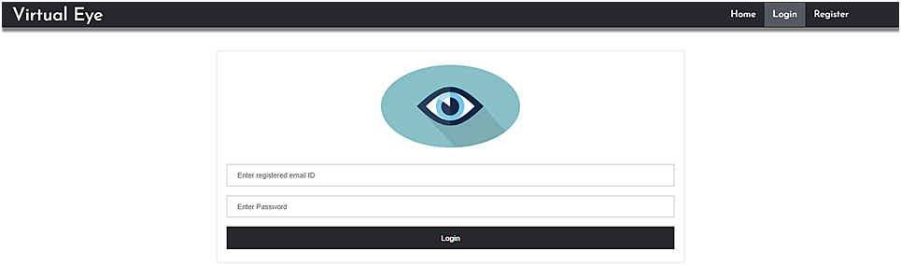

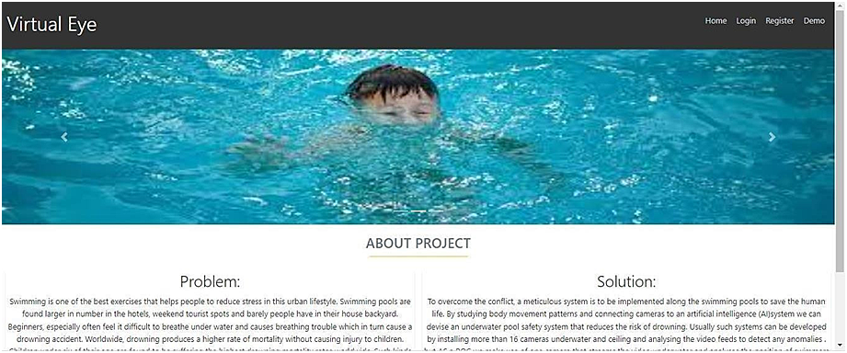

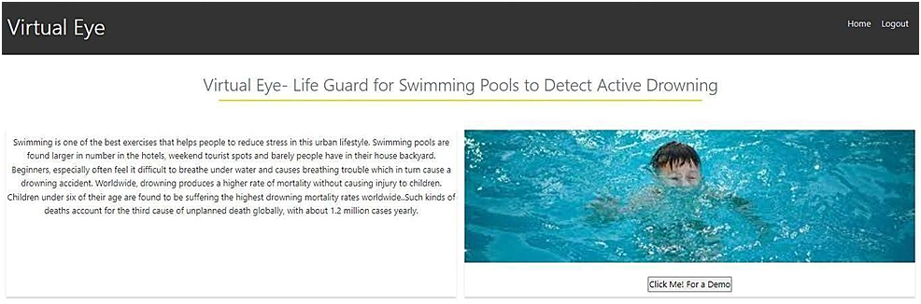

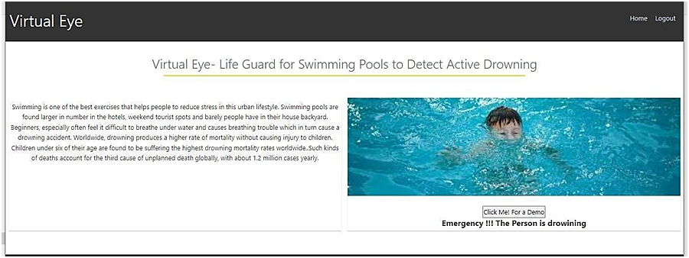

**CHAPTER-10**

#### 10.1 ADVANTAGES & DISADVANTAGES

**\*ADVANTAGES:**

1. user feel comfortable and more secure
2. Children, adult, pet animal , old age people are used
3. spending more time for family, freedom for safety guards near the Swimming pool
4. Swimmers, resort are gain in the financal
5. drowning should be monitored

\***DISADVANTAGE:**

For uneducated people will suffer from this technology

1. Electricity will be required
2. Software and hardware requirement will need

**CHAPTER-11**

**CONCLUSION**

This section will draw from three core documents: ISO_20380, HSG179, and the recently published German guideline, DGfdB R 94.15. A summary of each is given, outlining the key messages they disseminate and what this means for those involved with DDS.

ISO_20380 This documentfocuses on the requirements for the installation, operation, maintenance and performance of DDS, the testing methods, and the information required from the supplier in the operating manual. These international standards do not apply to systems used in domestic pools or pools smaller than 150m2 .

Prior to the installation of any DDS, ‘a technical study shall be carried out by the supplier in consultation with or based on information provided by the swimming pool’s owner/operator’. This is to establish the quantity and positioning of the equipment making up the system such as cameras,central processing unit, alarm tools, and other related equipment. The technical study must also provide a technical drawing of the pool basin, showing areas of ‘coverage’ and ‘non-coverage’, as well as the minimum lighting levels required above and below the water surface for the DDS to operate within performance requirements. To carry out the study, a list of factors to consider are given, outlining the variables that make each pool unique such as the architecture, and alarm reception coverage area of mobile devices to be used with the system. The next area of the standard is the performance requirements. This outlines the requirements needed to pass the regular maintenance testing and performance requirements for normal operation. This section covers the alarm set off time for operational performance, which is to be 15 seconds or less and displayed on the system interface. It also states that the alarm set off time must be built-in and shall not be changeable by staff.

**CHAPTER-12**

**Future work**

# vision-enabled

This lifeguard system consists of three main components, i.e., the drowning detection, the rescuing drone, and the hazardous activity detection. All three components combined will create a system capableof detecting drowningvictims, dispatching an inflatable tube using a drone (as depicted in Fig.9) and detecting hazardous activities—eventually becoming an entity that could assist a lifeguard. The system is accessible to its primary user, presumably a pool owner or a lifeguard, in the form of an interface with a sound alarm and an android mobile service that holds the capabilities of receiving Firebase notifications. Confined with a few of the hardware limitations, such as the use of a single camera and the Jetson Nano at the presence of better-quality hardware, could affectthe speed and accuracy of the overallsystem is becominga state-oftheart.

This limitation could be omitted with the use of multiple cameras that could be placed over the premises in several ground coordinates, increasing the accuracy of the computer vision algorithms. Moreover, due to the inability to fly a drone in extremeweather conditions such as rain, strong windsor lightning, the system is limited to be used under few specifications. As swimming in extreme weatherconditions is not preferred either, the system could be further improved to emit a warning signal if a person was to swim in any of the above weather conditions, bypassing the need to fly the drone. A For future developments convenience wise, the system could benefit by having an additional set of cameras to identify and verify a drowning or a hazardous activity on the premises. Accessibility could also be improved by extending the Android service to be an application both in Android and iOS platforms that could hold the details of each premise individually, making a centralized system that watches over the decentralized pool premises. Both drown and hazardous activity detection could be improved by gathering a night time dataset that increases the accuracy of the data in low light.

**CHAPTER-13**

## 13. APPENDIX

### (i) SOURCE CODE

[net]

# Testin g# batch=1 # subdivisions=1# Training batch=64 subdivisions=16 width=608 height=608 channels=3 momentum=0.9 decay=0.0005 angle=0 saturation = 1.5 exposure =

1.5hue=.1

learning_rate=0.01bu rn_in=1000 max_batches = 500200policy=steps steps=400000,450000 scales=.1,.1

[convolutiona

l]

batch_normali ze=1 filters=32 size=3 stride=1 pad=1 activation=l eaky

# Downsample

[convolutiona

l]

batch_normali ze=1 filters=64 size=3 stride=2 pad=1 activation=l

eaky

[convolutiona

l]

batch_normali ze=1 filters=32 size=1 stride=1 pad=1 activation=l

eaky

[convolutiona

l]

batch_normali ze=1 filters=64 size=3 stride=1 pad=1 activation=l

eaky

[shortcut]fro m=-3

activation=linear#

Downsample

[convolutiona

l]

batch_normali ze=1 filters=128 size=3 stride=2 pad=1 activation=l

eaky

[convolutiona

l]

batch_normali ze=1 filters=64 size=1 stride=1 pad=1 activation=l

eaky

[convolutiona

l]

batch_normali ze=1 filters=128 size=3 stride=1 pad=1 activation=l

eaky

[shortcut]fro m=-3

activation=linear

[convolutiona

l]

batch_normali ze=1 filters=64 size=1 stride=1 pad=1 activation=l

eaky

[convolutiona

l]

batch_normali ze=1 filters=128 size=3 stride=1 pad=1 activation=l

eaky

[shortcut]fro m=-3

activation=li near #

Downsamp

le

[convolutiona

l]

batch_normali

ze=1

filters=256si ze=3 stride=2 pad=1 activation=le aky

[convolutiona

l]

batch_normali ze=1 filters=128 size=1 stride=1 pad=1 activation=l

eaky

[convolutiona

l]

batch_normali ze=1 filters=256 size=3 stride=1 pad=1 activation=l

eaky

[shortcut]fro m=-3

activation=linear

[convolutiona

l]

batch_normali ze=1 filters=128 size=1 stride=1 pad=1 activation=l

eaky

[convolutiona

l]

batch_normali ze=1 filters=256 size=3 stride=1 pad=1 activation=l eaky

[shortcut]fro m=-3

activation=linear

[convolutiona

l]

batch_normali ze=1 filters=128 size=1 stride=1 pad=1 activation=l eaky [convolutiona

l]

batch_normali ze=1 filters=256

size=3

stride =1 pad=1 activation=leaky

[shortcut]fro m=-3

activation=linear

[convolutiona

l]

batch_normali ze=1 filters=128 size=1 stride=1 pad=1 activation=l

eaky

[convolutiona

l]

batch_normali ze=1 filters=256 size=3 stride=1 pad=1 activation=l

eaky

[shortcut]fro m=-3

activation=linear

[convolutiona

l]

batch_normali ze=1 filters=128 size=1 stride=1 pad=1 activation=l

eaky

[convolutiona

l]

batch_normali ze=1 filters=256 size=3 stride=1 pad=1 activation=l

eaky

[shortcut]fro m=-3

activation=linear

[convolutiona

l]

batch_normali ze=1 filters=128 size=1 stride=1 pad=1 activation=l

eaky

[convolutional]

batch_normali ze=1filters=2 56 size=3 stride=1 pad=1 activation=l

eaky

[shortcut]fro m=-3

activation=linear

[convolutiona

l]

batch_normali ze=1 filters=128 size=1 stride=1 pad=1 activation=l

eaky

[convolutiona

l]

batch_normali ze=1 filters=256 size=3 stride=1 pad=1 activation=l eaky

[shortcut]fro m=-3

activation=linear

[convolutiona

l]

batch_normali ze=1 filters=128 size=1 stride=1 pad=1 activation=l

eaky

[convolutiona

l]

batch_normali ze=1 filters=256 size=3 stride=1 pad=1 activation=l

eaky

[shortcut]fro m=-3

activation=linear#

Downsample

[convolutiona

l]

batch_normali ze=1 filters=512 size=3

stride=2

pad=1 activation=leaky

[convolutiona

l]

batch_normali ze=1 filters=256 size=1 stride=1 pad=1 activation=l

eaky

[convolutiona

l]

batch_normali ze=1 filters=512 size=3 stride=1 pad=1 activation=l

eaky

[shortcut]fro m=-3

activation=linear

[convolutiona

l]

batch_normali ze=1 filters=256 size=1 stride=1 pad=1 activation=l eaky

[convolutiona

l]

batch_normali ze=1 filters=512 size=3 stride=1 pad=1 activation=l

eaky

[shortcut]fro m=- 3 activation=linear

[convolutiona

l]

batch_normali ze=1 filters=256 size=1 stride=1 pad=1 activation=l

eaky

[convolutiona

l]

batch_normali ze=1 filters=512 size=3

stride=1

pad=1 activation=leaky

[shortcut]fro m=-3

activation=linear

[convolutiona

l]

batch_normali ze=1 filters=256 size=1 stride=1 pad=1 activation=l

eaky

[convolutiona

l]

batch_normali ze=1 filters=512 size=3 stride=1 pad=1 activation=l eaky [shortcut]fro m=-3

activation=linear

[convolutiona

l]

batch_normali ze=1 filters=256 size=1 stride=1 pad=1 activation=l

eaky

[convolutiona

l]

batch_normali ze=1 filters=512 size=3 stride=1 pad=1 activation=l

eaky

[shortcut]fro m=-3

activation=linear

[convolutiona

l]

batch_normali ze=1 filters=256 size=1 stride=1 pad=1 activation=l

eaky

[convolutional] batch_normali ze=1filters=5 12 size=3 stride=1 pad=1 activation=l

eaky

[shortcut]fro m=-3

activation=linear

[convolutiona

l]

batch_normali ze=1 filters=256 size=1 stride=1 pad=1 activation=l eaky

[convolutiona

l]

batch_normali ze=1 filters=512 size=3 stride=1 pad=1 activation=l

eaky

[shortcut]fro m=-3

activation=linear

[convolutiona

l]

batch_normali ze=1 filters=256 size=1 stride=1 pad=1 activation=l

eaky

[convolutiona

l]

batch_normali ze=1 filters=512 size=3 stride=1 pad=1 activation=l

eaky

[shortcut]fro m=-3

activation=linear#

Downsample

[convolutiona

l]

batch_normali ze=1 filters=1024 size=3

stride =2 pad=1 activation=leaky

[convolutiona

l]

batch_normali ze=1 filters=512 size=1 stride=1 pad=1 activation=l

eaky

[convolutiona

l]

batch_normali ze=1 filters=1024 size=3 stride=1 pad=1 activation=l

eaky

[shortcut]fro m=-3

activation=linear

[convolutiona

l]

batch_normali ze=1 filters=512 size=1 stride=1 pad=1 activation=l eaky

[convolutiona

l]

batch_normali ze=1 filters=1024 size=3 stride=1 pad=1 activation=l

eaky

[shortcut]fro m=-3

activation=linear

[convolutiona

l]

batch_normali ze=1 filters=512 size=1 stride=1 pad=1 activation=l eaky

[convolutiona

l]

batch_normali ze=1 filters=1024 size=3 stride=1 pad=1 activation=leaky

[shortcut]fro m=-3

activation=linear

[convolutiona

l]

batch_normali ze=1 filters=512 size=1 stride=1 pad=1 activation=l

eaky

[convolutiona

l]

batch_normali ze=1 filters=1024 size=3 stride=1 pad=1 activation=l

eaky

[shortcut]fro m=-3

activation=linear ################

######

[convolutiona

l]

batch_normali ze=1 filters=512 size=1 stride=1 pad=1 activation=l

eaky

[convolutional] batch_normalize=1 size=3 stride=1 pad=1 filters=1024

activation=leaky

[convolutiona

l]

batch_normali ze=1 filters=512 size=1 stride=1 pad=1 activation=l eaky

[convolutional] batch_normalize=1 size=3 stride=1 pad=1 filters=1024

activation=leaky

[convolutiona

l]

batch_normali ze=1 filters=512 size=1 stride=1 pad=1 activation=l

eaky

[convolutional] batch_normalize=1 size=3 stride=1 pad=1 filters=1024

activation=leaky

[convolutional]s ize=1 stride=1 pad=1 filters=255ac tivation=line ar

[yolo]

mask = 6,7,8 anchors = 10,13,16,30, 33,23, 30,61, 62,45, 59,119, 116,90,

156,198, 373,326

classes=80 num=9

jitter=.3 ignore_thre sh = .7

truth_thresh = 1random=1

[route] layers = -4

[convolutiona

l]

batch_normali ze=1 filters=256 size=1 stride=1 pad=1 activation=l

eaky

[upsamp le]

stride=2

[route] layers = -1, 61

[convolutional]

batch_normali ze=1filters=2 56 size=1 stride=1 pad=1 activation=l

eaky

[convolutional] batch_normalize=1 size=3 stride=1 pad=1 filters=512

activation=leaky

[convolutiona

l]

batch_normali ze=1 filters=256 size=1 stride=1 pad=1 activation=l

eaky

[convolutional] batch_normalize=1 size=3 stride=1 pad=1 filters=512 activation=leaky [convolutiona

l]

batch_normali ze=1 filters=256 size=1 stride=1 pad=1 activation=l

eaky

[convolutional] batch_normalize=1 size=3 stride=1 pad=1 filters=512

activation=leaky

[convolutional]s ize=1 stride=1 pad=1 filters=255ac tivation=line ar

[yolo] mask = 3,4,5

anchors = 10,13,16,30, 33,23, 30,61, 62,45, 59,119, 116,90,

156,198, 373,326 classes=80 num=9 jitter=.3 ignore_thre sh = .7

truth_thresh = 1random=1

[route] layers = -4

[convolutiona

l]

batch_normali ze=1 filters=128 size=1 stride=1 pad=1 activation=l

eaky

[upsamp le]

stride=2

[route] layers = -1, 36

[convolutiona

l]

batch_normali ze=1 filters=128 size=1 stride=1 pad=1 activation=l

eaky

[convolutional] batch_normalize=1 size=3 stride=1 pad=1 filters=256

activation=leaky

[convolutiona

l]

batch_normali ze=1 filters=128 size=1 stride=1 pad=1 activation=l eaky

[convolutional] batch_normalize=1

size=3 stride=1

pad=1 filters=256ac tivation=lea ky [convolutiona

l]

batch_normali ze=1 filters=128 size=1 stride=1 pad=1 activation=l

eaky

[convolutional] batch_normalize=1 size=3 stride=1 pad=1 filters=256

activation=leaky

[convolutional]s ize=1 stride=1 pad=1 filters=255ac tivation=line ar

[yolo] mask = 0,1,2

anchors = 10,13,16,30, 33,23, 30,61, 62,45, 59,119, 116,90,

156,198, 373,326

classes=80 num=9

jitter=.3

ignore_thre sh = .7 truth_thresh =

1random=1

**Source code(ii)**

#import necessary packagesimport cv2 import os

import numpy as np

from .utils import download_file

initialize = Truenet = None

dest_dir = os.path.expanduser('~') + os.path.sep + '.cvlib' + os.path.sep + 'object_detection' +os.path.sep + 'yolo' + os.path.sep + 'yolov3'

classes = None

#colors are BGR instead of

RGB in python COLORS =

[0,0,255], [255,0,0]

def populate_class_labels():

#we are using a pre existent classifier which is more reliable and more efficient than one#we could make using only a laptop #The classifier should be downloaded automatically when you run this scriptclass_file_name = 'yolov3_classes.txt' class_file_abs_path = dest_dir + os.path.sep + class_file_name

url = 'https://github.com/Nico31415/DrowningDetector/raw/master/yolov3.txt'if not os.path.exists(class_file_abs_path): download_file(url=url, file_name=class_file_name, dest_dir=dest_dir)f

= open(class_file_abs_path, 'r') classes = [line.strip() for line in f.readlines()]

return classes

def get_output_layers(net)

#the number of output layers in a neural network is the number of possible#things the network can detect, such as a person, a dog, a tie, a phone... layer_names = net.getLayerNames()

output_layers = [layer_names[i[0] - 1] for i in

net.getUnconnectedOutLayers()]

return output_layers

def draw_bbox(img, bbox, labels, confidence, Drowning,write_conf=False):

global

COLORS

global classes

if classes is None:

classes = populate_class_labels()

for i, labelin enumerate(labels):

#if the person is drowning, the box will be drawn red instead of blueif label == 'person'and Drowning: color = COLORS[0] label

= 'DROWNING'

else:

color = COLORS[1]

if write_conf: label += ' ' + str(format(confidence[i] * 100, '.2f')) +'%'

#you only need to points (the opposite corners) to draw a rectangle. These points#are stored in the variable bbox cv2.rectangle(img, (bbox[i][0],bbox[i][1]), (bbox[i][2],bbox[i][3]), color,2)

cv2.putText(img, label, (bbox[i][0],bbox[i][1]-10), cv2.FONT_HERSHEY_SIMPLEX, 0.5, color, 2)

return img

def detect_common_objects(image,

confidence=0.5, nms_thresh=0.3):

Height, Width =

image.shape[:2]scale =

0.00392

global classes global dest_dir

#all the weights and the neuralnetwork algorithm are already preconfigured#as we are using YOLO

#this part of the script just

downloads the YOLO filesconfig_file_name =

'yolov3.cfg' config_file_abs_path = dest_dir+ os.path.sep + config_file_name

weights_file_name = 'yolov3.weights'

weights_file_abs_path = dest_dir+ os.path.sep

+ weights_file_name

url = 'https://github.com/Nico31415/Drowning-

Detector/raw/master/yolov3.cfg'

if not os.path.exists(config_file_abs_path): download_file(url=url, file_name=config_file_name, dest_dir=dest_dir)

url = 'https://pjreddie.com/media/files/yolov3.weights'

if not os.path.exists(weights_file_abs_path):

download_file(url=url, file_name=weights_file_name,dest_dir=dest_dir)

global initialize global net

if initialize:

classes = populate_class_labels()

net = cv2.dnn.readNet(weights_file_abs_path, config_file_abs_path)initialize = False

blob = cv2.dnn.blobFromImage(image,scale, (416,416), (0,0,0), True, crop=False)

net.setInput(blob)

outs = net.forward(get_output_layers(net))

class_ids =

[]

confidenc

es = [] boxes= []

for out in outs:

for detection in out: scores = detection[5:] class_id = np.argmax(scores) max_conf =

scores[class_id] if max_conf > confidence: center_x = int(detection[0] *

Width) center_y =

int(detection[1] * Height)w = int(detection[2] * Width) h = int(detection[3] *

Height)x = center_x - w

/ 2 y = center_y - h / 2 class_ids.append(class_id) confidences.append(float(max_conf))bo xes.append([x, y, w, h])

indices = cv2.dnn.NMSBoxes(boxes, confidences, confidence, nms_thresh)

bbox = [] label = [] conf = [] for i in indices:

i = i[0]

box =

boxes[i]x = box[0] y = box[1] w = box[2] h = box[3] bbox.append([round(x), round(y),round(x+w), round(y+h)]) label.append(str(classes[class_ids[i]])) conf.append(confidences[i])

return bbox, label, conf

**Git hub Link:**

https://github.com/IBM-EPBL/IBM-Project-50448-1660909679

[IBM-EPBL](https://github.com/IBM-EPBL)/[**IBM-Project-50448-1660909679**](https://github.com/IBM-EPBL/IBM-Project-50448-1660909679)